

Daniel De Sousa and Tynan Sears

July 2017 -

**1. Introduction**

**1.1 Abstract**

09/10/17

Daniel De Sousa

The purpose of this project is to build a smartwatch which is able to connect to a mobile device and display information such as incoming calls, messages, time, date, and other statistics obtained using any onboard sensors. The goal of this project is to not only learn about concepts such as hardware design, software, and project management but to also build a feasible wearable prototype which can be used to obtain one's biometric information throughout their day. This data can then be analyzed by the user after they extract the data from the watch or in real-time by an application. The later stages of this project will consist of perfecting the mechanical and electrical design, optimizing the firmware, designing an analytics platform, and developing new specifications which will improve the project.

**1.2 Specifications**

09/10/17

Daniel De Sousa

Original specifications for this project were developed over a period of 2 months and were based on previous smartwatch designs and what was found to be vital for the successful completion of this project. The following specifications were developed:

* Connects to and exchanges information and data with a mobile device
* Measures heart rate, counts steps, and keeps track of current time and date
* Stores step, heart rate, and time information in non-volatile memory
* Displays time, step information, heart rate, connection status,and incoming notifications
* Charging capability

The means for how these specifications will be met will be using the following devices:

* Microcontroller to control peripherals, data allocation, and signal processing
* Bluetooth connectivity to allow for wireless communication between the device and a mobile device
* Photoplethysmogram sensor to obtain and measure heart rate data
* Accelerometer to obtain and measure step information
* Real time clock to measure and keep track of time
* A display to display information
* Recharger integrated circuit to allow for recharging capability

The following figure describes which communication protocol the microcontroller will use to communicate with each peripheral.

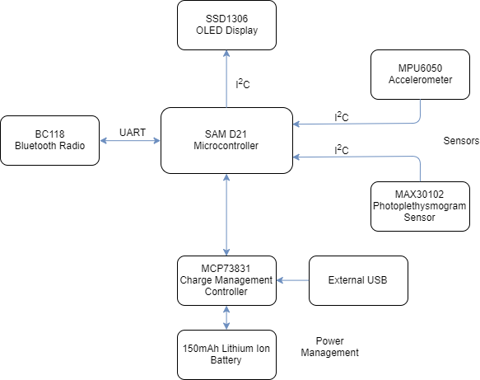

**Figure 1**: Communication Protocols Used Between Peripherals and Microcontroller

The outlined specifications are the minimum specifications to be implemented for the successful completion of the project and they will be updated as this project is worked on. The components will be updated as the design becomes optimized and new specifications are developed.

**2. Hardware**

This section describes the specific hardware involved in the functioning of the smartwatch. Section includes schematics, background information on how the component operates, and a general system overview.

**2.1 Processor**

09/10/17

Daniel De Sousa

A microcontroller will be used to control the multiple onboard peripherals, obtain data from the various sensors, and perform any analysis required. An Atmel SAM D21 microcontroller is chosen for its low cost, low power, wide support, numerous communication busses, and compatibility with the Arduino platform. The SAM D21 has the following specifications:

* ARM Cortex-M0+ processor running up to 48 MHz
* 256 KB of embedded flash and 32 KB of SRAM
* Low power consumption at less than 70 uA/MHz
* 6 flexible serial communication modules (SERCOM) which can act as SPI, UART, I2C bus
* Embedded full speed USB device and host
* 14 12-bit ADC channels and 1 10-bit DAC channel
* Internal 32-bit Real Time Clock

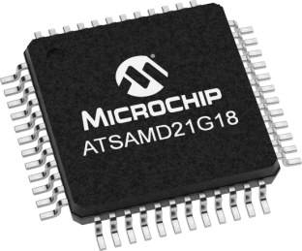

**Figure 2**: SAM D21 Microcontroller

The pinout for this microcontroller is as follows:

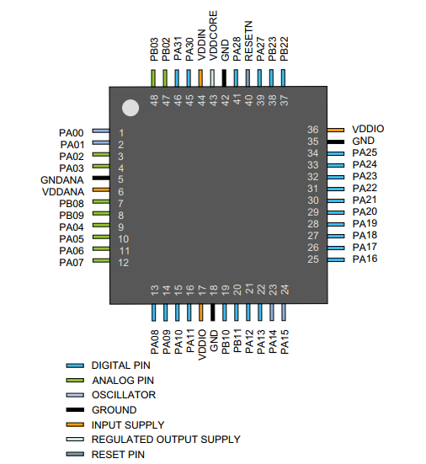

**Figure 3**: SAM D21 Pinout

The SAM D21 mini breakout by Sparkfun Electronics contains this microcontroller and is used in order to begin working on the peripherals and begin prototyping using different modules.

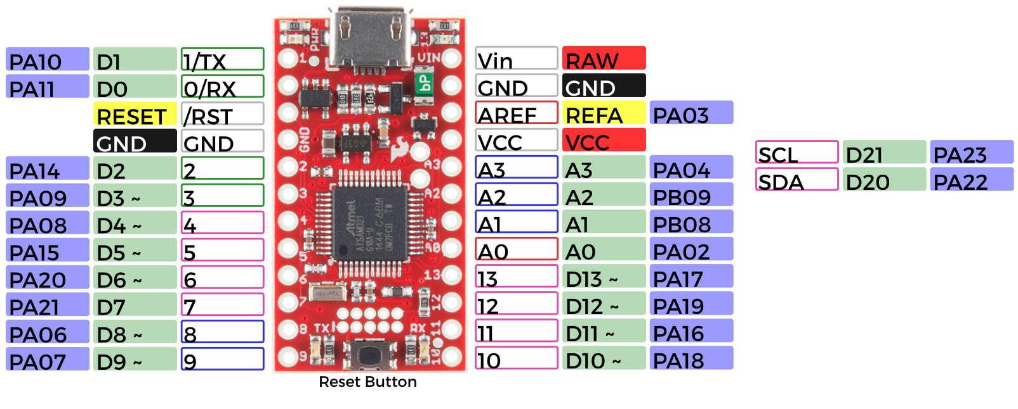

**Figure 4**: SAM D21 Mini Breakout

The SAM D21 will be programmed over USB using the Arduino bootloader. On the SAM D21 mini breakout, the SAM D21 is pre-programmed with the Arduino bootloader. If a bare SAM D21 is being used such as the one used on the custom PCB, the Arduino bootloader will be need to be burned in by the user using an Atmel Ice Debugger.

**2.2 Heart Rate Sensor** 09/10/17

Daniel De Sousa

Photoplethysmography is an optical technique used to determine pulse by detecting changes in blood volume in the microvascular bed of the tissue. Changes are detected by illuminating an area of the skin and measuring the amount of light which is reflected. The amount of light which is reflected varies when the blood flows as the composition, concentration, and orientation of red blood cells changes depending on whether the heart is in systole or diastole. These changes cause an overall change in the pulse pressure resulting in a change of light absorbance which can then be detected by a sensor.

To determine the users heart rate, a MAX30102 high-sensitivity pulse oximeter and heart rate sensor is used. The main components of this sensor consist of red and infrared LEDs, which emit light onto the skin, a photodiode which detects how much light is reflected by converting any absorbed light into electrical current, ADC busses which convert the analog signal emitted from the photodiode to a digital signal, and digital filters used to cancel out any ambient noise. The MAX30102 functional diagram can be seen in **Figure 5**.

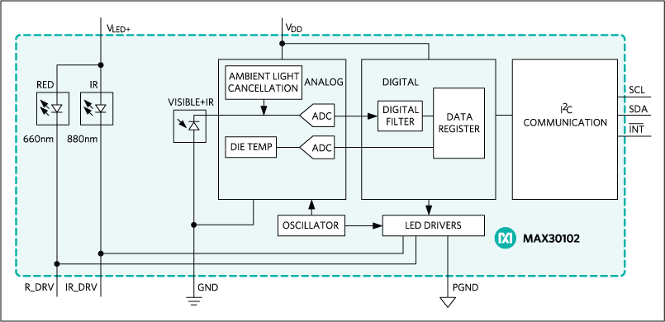

**Figure 5**: MAX30102 Functional Diagram

This sensor is placed on the forearm of the subject and connects to the SAM D21 using I2C.

In addition to the MAX30102 sensor, a MAX1921 DC-DC converter is also used to convert the input voltage down to the MAX30102 reference voltage of 1.8V. A MAX14592 level translator as seen in **Figure 6** is used to convert logic levels up to 3.3V and down to 1.8V. These are required as the SAM D21 exhibits 3.3V logic.

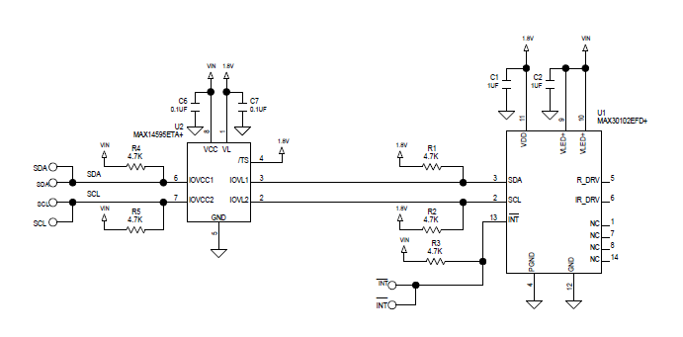

**Figure 6**: MAX301012 Level Shifting

Previously, the SEN-11574 pulse sensor was used to detect the user's heart rate.This sensor was less complex but also less accurate. Its main components consisted of a red LED, a photodiode, and a operational amplifier which increased the magnitude of the analog signal. This sensor connected directly to one of the SAM D21’s ADC pins. In addition to the sensor, a high-pass filter was implemented between the sensor and the microcontroller to remove the DC component of the signal. A low-pass filter is used in series with the high-pass filter to form a bandpass filter and is used to attenuate signal frequencies higher than the specific range. These unwanted frequency ranges do not make up the actual PPG signal and need to be removed in order to produce a more accurate signal and ease processing. This filter removes all signals besides ones operating in the frequency range between 0.6 and 6 Hz. A schematic of the PPG sensor, the microcontroller and the filter can be seen in **Figure 7**.

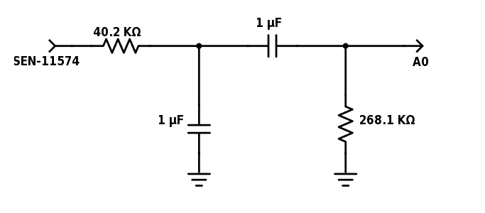

**Figure 7**: Schematic of Bandpass Filter Used With PPG Sensor

**2.3 Accelerometer**

11/01/17

Tynan Sears

An InvenSense MPU-6050 6-axis IC is used to track the users motion and count steps The MPU-6050 consists of a MEMS (Micro-Electro-Mechanical System) accelerometer as well as a MEMS gyroscope, a temperature sensor and a digital motion processor (DMP).

MEMS are small mechanical structures which are made up of mass and spring structure that when moved or accelerated, cause changes in electrical capacitance within the internal structures. These changes are analyzed by an internal processor which can then output values such as accelerations or rotations. **Figure 8** is an example of a basic MEMS gyroscope device.

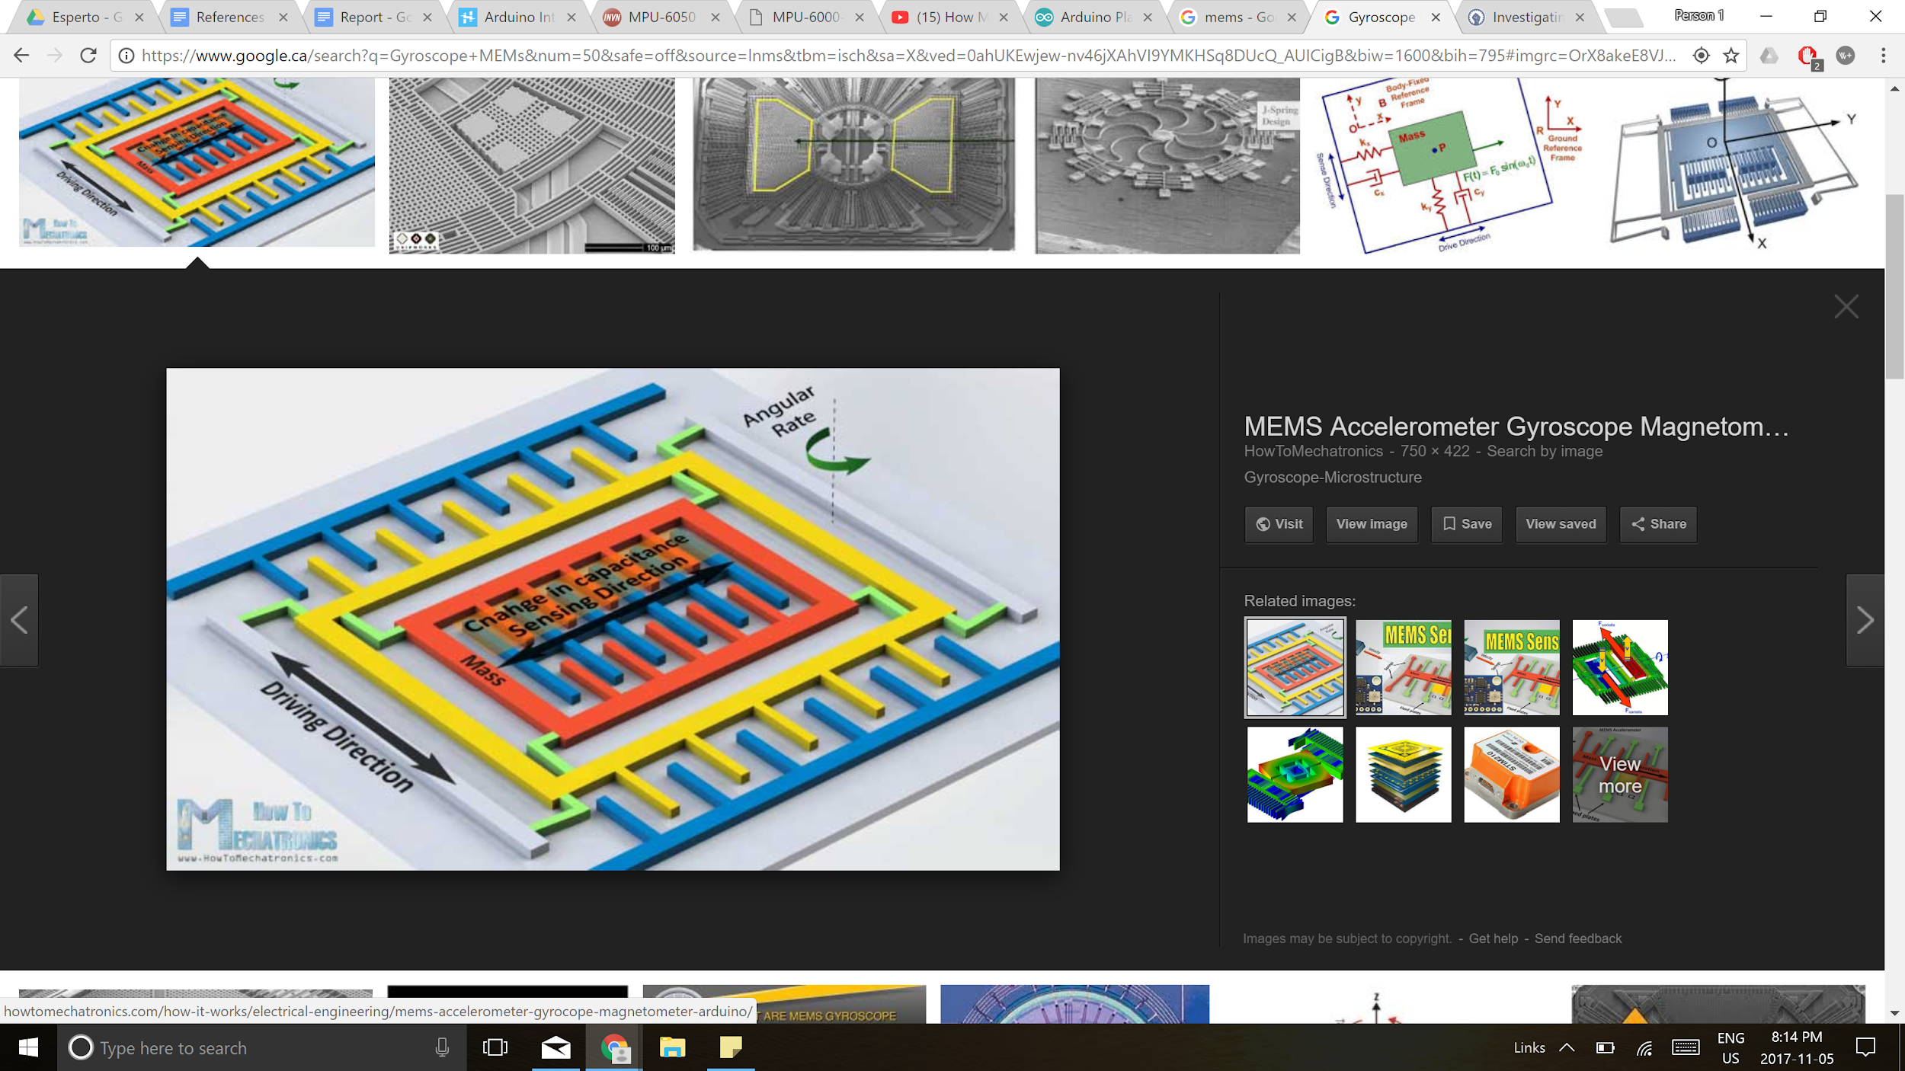

**Figure 8**: A Basic MEMS Structure for a Gyroscope

The internal processor found in the MPU-6050 is called the DMP or digital motion processor. It is used to compute complex multi-axis algorithms and calculations such as quaternions, euler angles, and more. This data is then stored in a FIFO buffer which can be accessed by the SAMD 21 via I2C. The DMP block diagram can be found in **Figure 9**.

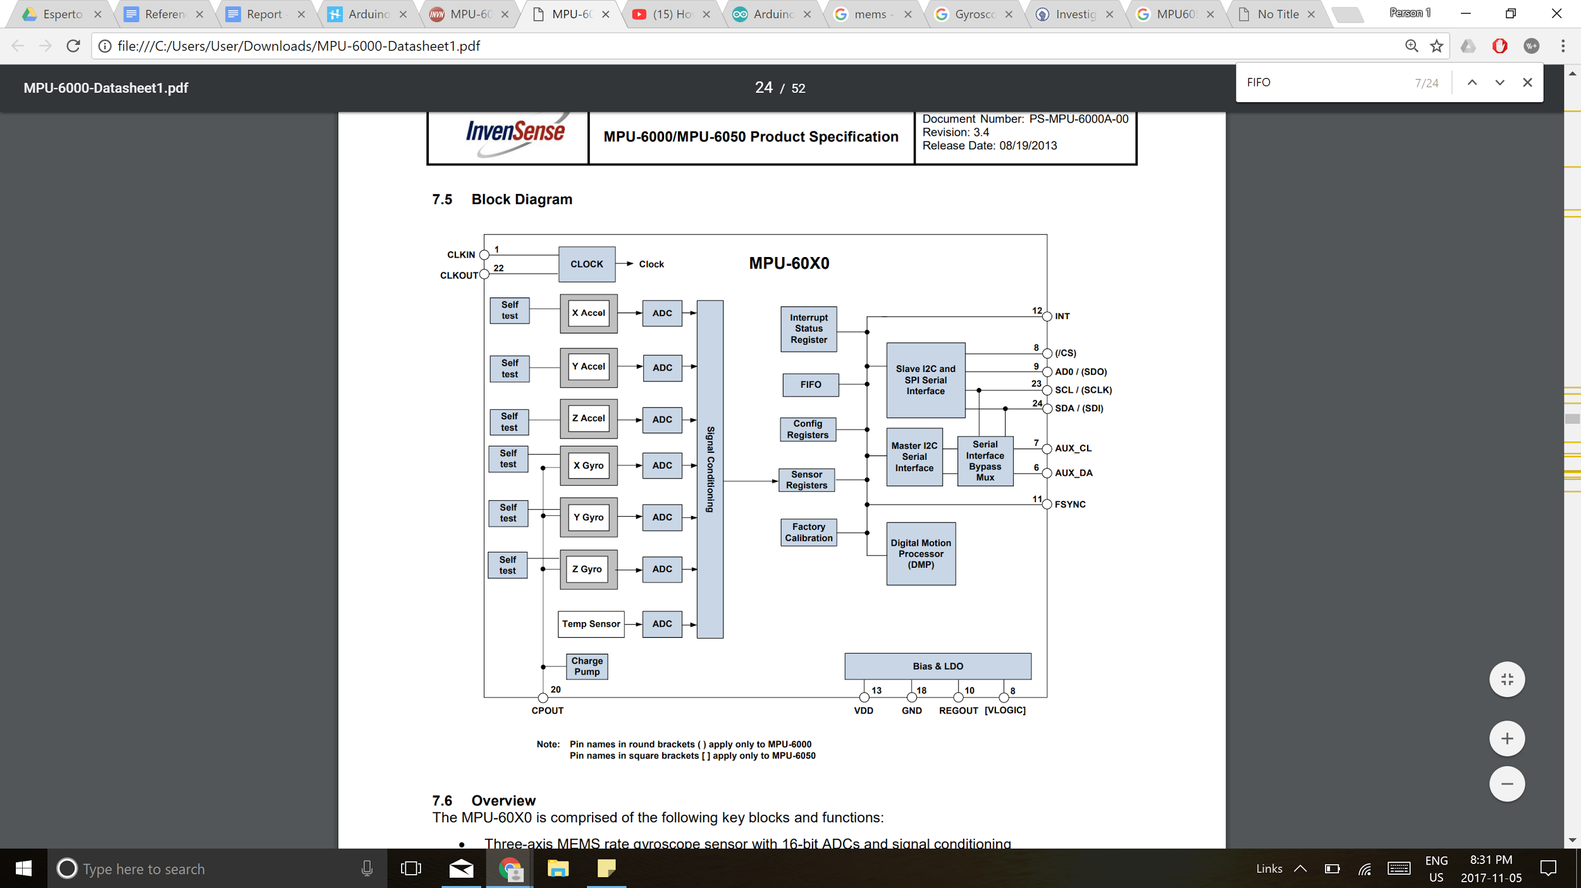

**Figure 9:** Block diagram of the MPU-6050

The MPU-6050 is directly connected to the I2C bus on the SAM D21. Some additional capacitors connected to some of the MPU-6050 pins are required as seen in **Figure 10.**

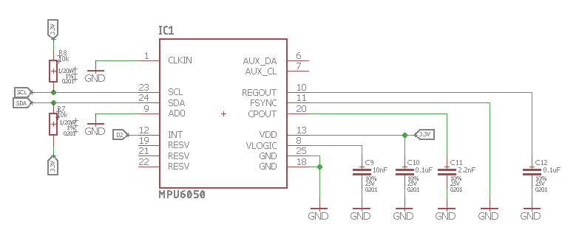

**Figure 10**: MPU-6050 Schematic

**2.4 Bluetooth Communication**

09/24/17

Daniel De Sousa

Bluetooth communication between a mobile device and the watch is established using a BC118 RF transceiver by BlueCreation. This module supports Bluetooth Low Energy and sends and receives information from the SAM D21 using the UART (Universal Asynchronous Receiver/Transmitter) interface. As seen in **Figure 11**, no other components besides a decoupling capacitor were required in using this module.

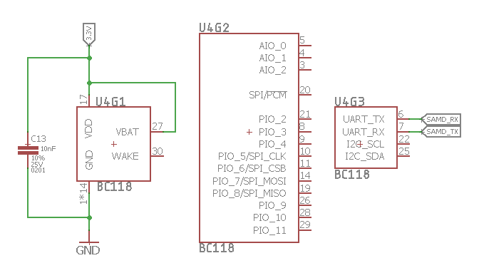

**Figure 11:** BC118 Schematic

**2.5 Display**

12/27/17

Daniel De Sousa

An OLED (Organic Light Emitting Diode) display is used to show information such as the time, date, heart rate, steps taken, battery status, connectivity status, incoming calls, and incoming texts.

In contrast to the traditional LED displays and their use of n or p-type layers, OLED displays contain organic molecules which are used to create holes and electrons. Simple OLED displays contain 6 different layers. The top and bottom layers are made of protective glass and plastic and are called the seal and substrate. The second-most inner layers are the anode and cathode which receive and release the electrons when an electrical potential is present between them. The innermost layers are made up of organic molecules and are called the conductive and emissive layer. Most of the visible light produced by a OLED display is created in the emissive layer. An additional colour filter can be added underneath the seal to create different colours. The 6 layers used in a OLED display can be found in **Figure 12.**

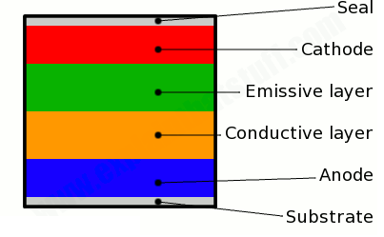

**Figure 12:** OLED Layers

For the OLED to operate, a voltage potential must be present between the anode and cathode layers. The flow of current causes electrons to flow from the cathode to the anode resulting in a negatively charged emissive layer and a positively charged conductive layer. The positive holes in the conductive layer and the electrons in the emissive layer are attracted to each other due to electrostatic forces. Since the electron holes are more mobile, they can ‘jump’ with more ease to the emissive layer. When the electron hole and electron meet, they form an exciton and release energy in the form of a photon in a process called recombination.

In this application, a PMOLED (Passive Matrix OLED) is used. These displays have anode and cathode strips arranged perpendicularly as seen in **Figure 13**. The intersection of these two strips create a pixel. Current is driven by a display driver into different pixels to create an image or text. The display driver used is an SSD1306 which communicates to the processor using I2C.

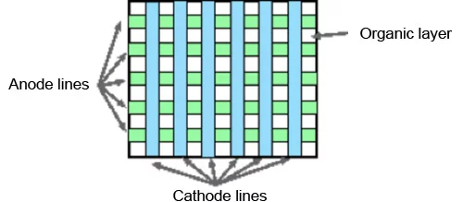

**Figure 13**: Cathode and Anode Lines Forming a Pixel

**2.6 Real Time Clock**

12/27/17

Daniel De Sousa

A Real Time Clock or RTC is a clock which can be used to keep track of world time. The SAM D21 microcontroller contains a 32-bit RTC with calendar functions to keep track of both date and time. This timer uses the external 32.768 KHz crystal.

**2.7 Power Management**

10/16/17

Daniel De Sousa

To wirelessly power the device, a battery and charging circuit have been implemented. The battery as seen in **Figure 14**, a 150 mAh rechargeable LiPo battery, is rated at 3.7 V equipped with a protection circuit to protect the battery from failures due to events such as over discharge. A MCP73831 linear charger integrated circuit is used to charge and detect the state of the battery.

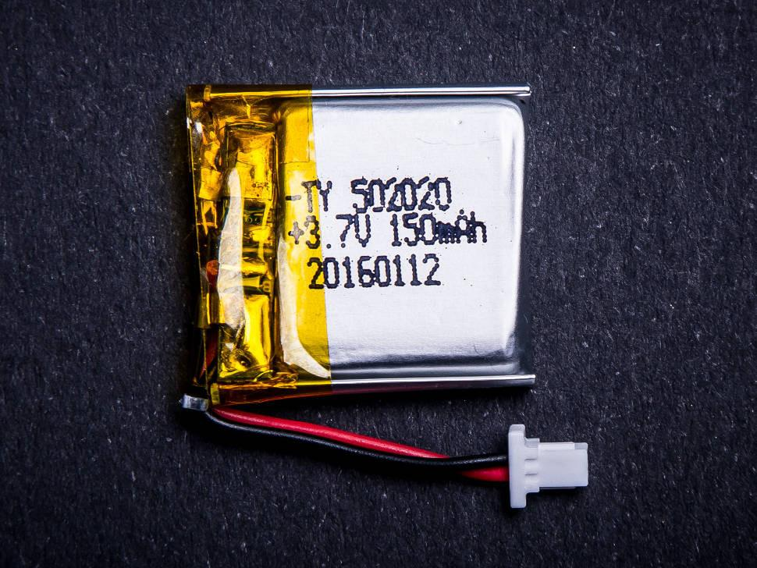

**Figure 14**: 3.7 V, 150 mAh LiPo Battery’

**LiPo Battery**

LiPo or Lithium Polymer batteries work using intercalation and deintercalation which is the reversible inclusion or insertion of an ion into materials of a layered structure. This occurs between a positive and negative electrode material where a liquid electrolyte such as Lithium salts provides a medium allowing conduction. A microporous separator is added to isolate the two materials and only allows the ions to migrate between the materials used, not allowing the two materials to make contact and short circuit. In LiPo batteries, the cathode is Lithium and the anode is Graphite. During discharge, ions from the Graphite material travel through the electrolyte and microporous separator to the Lithium material. During charging, the electrons return to the anode resulting in a higher energy state. The chemical reaction is as follows with the charging state on the left and the discharging state on the right:

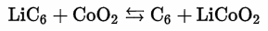

Adding energy (charging) causes this reaction to proceeds towards the left where a lack of energy causes the reaction to proceed to the right and discharge. An image of the ongoing reaction can be seen in **Figure 15**.

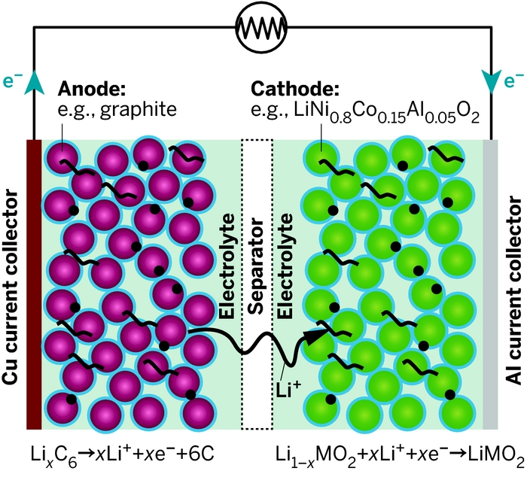

**Figure 15**: Lithium Polymer Batteries Electrochemistry

Once the battery is completely charged, it will slowly begin to discharge. The battery level can be measured by sampling its voltage.

The benefits of LiPo batteries are that they are inexpensive, have large capacities for their small sizes, and can come in many different shapes.

**MCP73831 Linear Charger**

The MCP73831 controller is used to charge the LiPo battery and reverse the electrochemical reaction between the Carbon and Lithium materials. This device is also able to provide an output status voltage which can be used to detect the status of the battery. This device takes an unregulated input voltage and outputs a regulated current of 100 mA to the battery in order to charge it. This current is determined by the resistor connected to the PROG pin of the MCP controller. **Figure 16** displays how power is managed on the watch and includes the methods of regulating a input supply and switching between different supplies.

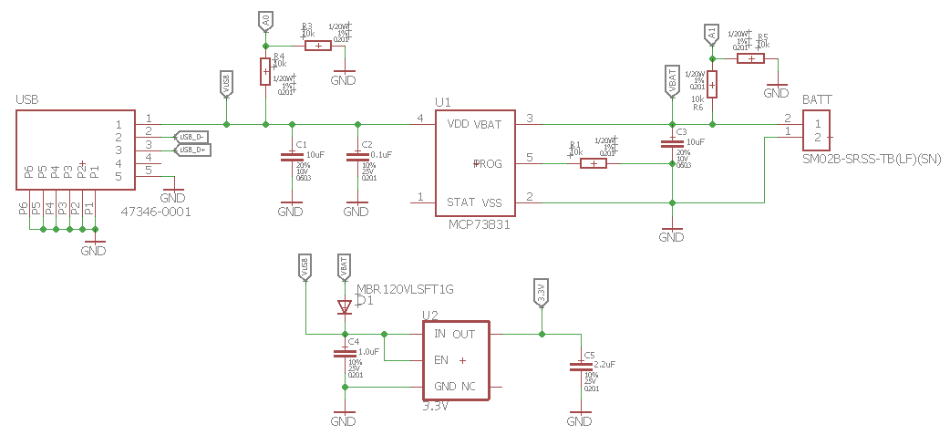

**FIgure 16:** Power Management Schematic

The watch can be powered using the connected battery or via USB. Using a switch-mode power supply in the form of a schottky diode, the board can be powered by either supply but the USB supply will take precedence even if a battery is plugged in. The input supply passes through a 3.3V low dropout regulator before being distributed to the SAM D21 processor and the rest of the modules. Two voltage divider circuits can be found on the schematic. These voltage dividers are used to halve the voltage preceding the analog inputs of the SAM D21 as the microcontroller has an analog pin tolerance of 3.3V and anything greater can damage the device.

**3. Firmware**

This section describes the design process behind the microcontroller firmware used to control and process data from each peripheral. Section includes information on the overall algorithm, code samples, and any error checking and noise removing methods implemented.

**3.1 Processor**

09/10/17

Daniel De Sousa

The firmware for the microcontroller is updated using the Arduino IDE as the microcontroller is Arduino compatible. The firmware is supported by the Arduino bootloader and has one main sketch file containing most of the code written for this project. The sketch file is written in C/C++ and consists of a setup() function which runs when the program is initialized, a loop() function which runs periodically at a declared frequency, and other supporting functions.

**3.2 Heart Rate Sensor** 09/11/17

Daniel De Sousa

**Algorithm**

The firmware affiliated with the heart rate sensor consists of one supporting function, calculateHR(), which is called in the main loop() function. This function begins by obtaining the infrared value from the sensor. This value is passed into an external function called checkForBeat() which does most of the processing and determines whether a heartbeat has occurred or not. If a heartbeat is detected, the time at which the heartbeat occured is stored in milliseconds. Two time variables have been created to determine the length of time in milliseconds between two adjacent heartbeats. Using this time difference, the heart rate in beats per minute can then be calculated. This heart rate is then placed into a circular queue containing the previous 5 heart rates calculated. This array allows a running average to be calculated and returned instead of only returning the current heart rate. Using this array will reduce inconsistencies in the heart rate values as any outliers will not drastically change the heart rate value being displayed. Instead, one average heart rate value will be displayed which represents the subjects heart approximately over the past 5 seconds.

A sample PPG signal can be seen in **FIgure 17**.

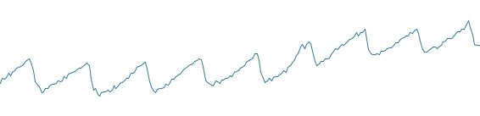

**Figure 17**: Sample PPG Signal

**Heartbeat Detection**

As mentioned above, the checkForBeat() function is an external function that takes in sample data received from the MAX30102 sensor and returns a boolean which determines whether a heartbeat has occurred or not. This function uses a derivative of the PBA (Peripheral Beat Amplitude) algorithm developed by Maxim Integrated. It works by keeping track of two adjacent data points and a peak and trough value. The function also uses two variables named ‘positiveEdge’ and ‘negativeEdge’ to keep track of if the current data is exhibiting a positive or negative slope. The peak and trough values are constantly updated if the correct conditions are met. As seen below, to update the peak value, the slope must be positive and the current data sample must be greater than the previous.

if (positiveEdge & (IR_AC_Signal_Current > IR_AC_Signal_Previous))

{

IR_AC_Signal_max = IR_AC_Signal_Current;

}

To update the trough value, the slope must be negative and the current data sample must be less than the previous.

if (negativeEdge & (IR_AC_Signal_Current < IR_AC_Signal_Previous))

{

IR_AC_Signal_min = IR_AC_Signal_Current;

}

A heartbeat is checked for every time the data crosses the 0 boundary line with a positive slope. If the difference between the peak and trough are large enough, then a heartbeat is reported and the function returns ‘true’.

Before a sample is used in any of these functions, it is first filtered against two filters as outlined in the next subsection.

**Heart Rate Filtering**

The function, checkForBeat(), uses two digital filters against incoming sample data points before checking for a heartbeat.

The first filter used is a Single Pole Recursive Low-Pass Filter. It is used to ‘smooth’ out the data set and remove any unwanted high frequency noise. This filter is implemented by storing a moving average as a 32-bit integer called ‘ir_avg_reg’. This filter is an example of a IIR filter as its impulse response will never equal zero but will instead continue indefinitely.

To update the moving average using the latest data sample, the function averageDCEstimator(int32_t *p, uint16_t x) is used. The function expects a pointer to an integer which stores the current moving address and the latest data sample. To increase efficiency while maintaining accuracy, fixed point arithmetic is used which allows the storage of a whole number and fraction in one integer. The incoming address is bit shifted 15 bits to the left (equivalent of multiplying it by 32768), the current moving average is then subtracted from it and the entire sum is bit shifted to the right by 4 bits (equivalent of dividing it by 16). This sum is then added to the current moving average and the moving address is returned shifted to the right by 15 bits (equivalent of dividing it by 32768) and stored in a variable called ‘IR_Average_Estimated’. The last bit shift is required as the sample value was bit shifted by 15 bits earlier when it was passed into the function. The ‘IR_Average_Estimated’ value is used later in the next filter. Fixed point arithmetic and bit shifting is used instead of division as it is much more efficient, especially when dealing with larger numbers. One bit-shift only requires one clock cycle where long division requires many more clock cycles and thus, requires more processing power. The entire function is seen below:

IR_Average_Estimated = averageDCEstimator(&ir_avg_reg, sample);

int16_t averageDCEstimator(int32_t *p, uint16_t x)

{

*p += ((((long) x << 15) - *p) >> 4);

return (*p >> 15);

}

This function is equivalent to:

Ir_avg_reg = (15/16)*Ir_avg_reg + (1/16)*sample

IR_Average_Estimated = Ir_avg_reg/32768 // 2^15 = 32768

The coefficients in front of ‘Ir_avg_reg’ and ‘sample’ are called the recursion coefficients where the ‘a’ value is multiplied by the incoming sample (1/16) and the ‘b’ value is multiplied by the previously calculated values from the output signal (15/16). The recursive coefficients are used to determine the type of filter used and how much decay in the signal is wanted. For a single-pole low pass filter, the coefficients must follow the following equations:

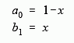

where ‘x’ is the amount of decay present between adjacent examples.

**Figure 18** displays what the result of using a recursive filter will look like, seperating an input into its high and low frequency components.

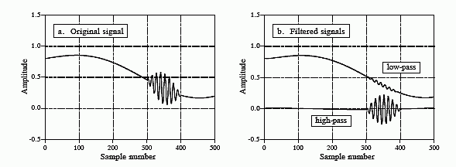

**Figure 18**: Input and Output After Using a Recursive Filter

The second filter used is a 12th order Low-Pass Finite Impulse Response Filter. This is an example of a FIR filter as its impulse response is of finite length as it proceeds to 0 over time. This filter is used on the incoming data samples when the lowPassFIRFilter(int16_t sample) function is called. The original sample minus the moving address is passed in as seen below.

IR_AC_Signal_Current = lowPassFIRFilter(sample - IR_Average_Estimated);

This function uses a 32 index buffer to store the 32 latest samples obtained from the sensor and a variable called ‘offset’ which is used to keep track of the current index. This buffer was implemented in a circular FIFO manner where the ‘offset’ variable wraps around to the beginning once it reaches the end of the queue as seen below.

offset++;

offset %= 32;

The heart of this function is the FIR filter. The output of an FIR filter is a weighted sum of the most recent N inputs, where N is an arbitrary number. A sample block diagram of a general FIR filter can be seen in **Figure 19** where the b coefficients are constant weights**.**

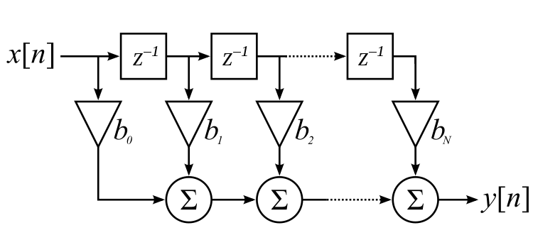

**Figure 19:** General Moving Average Filter

The FIR filter can also be defined using the following formula and summation:

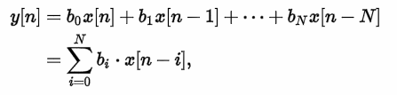

where y[n] is the output of the filter, x[n] is the input of the filter, b represents the coefficients used, and N is the filter order. In the case of this FIR filter, N is equal to 23 meaning that there are 23 taps in the filter and that the 23 most recent sample values are multiplied by a coefficient and than summed together to equal the output of the filter. Although N is equal to 23, the filter order is actually only 12 since only 12 distinct coefficients are used. The coefficients used are stored in the following array:

static const uint16_t FIRCoeffs[12] = {172, 321, 579, 927, 1360, 1858, 2390, 2916, 3391, 3768, 4012, 4096};

where each of these coefficients are used twice except for the last index of the array which is used only once. Note that only 23 of the 32 samples in the sample array used in the filtering process. The 9 oldest samples are never used and are simply overwritten when incoming sample data is processed. Out of the 23 most recent samples, the least recent sample is multiplied by the 0th index in the array while the 2nd least recent sample is multiplied by the 1st index until the 12th least recent sample is multiplied by the 11th index. The 13th least recent sample is multiplied by the 10th index and it goes back to the beginning where the most recent sample is multiplied by the coefficient found at the 0th index. **Figure 20** demonstrates this where b1 is multiplied by the least recent value and b23 is multiplied by the most recent value. The coefficients in this filter form a normal distribution curve.

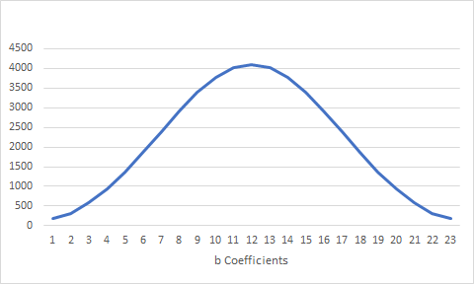

**Figure 20**: FIR Coefficients

These coefficients are determined by a filter design program and represent the transfer function which is the Z transform of the impulse response. The transfer function can be written as:

H(z) = 172+ 321 z-1 + 579 z-2 + 927 z-3 + 1360 z-4 + 1858 z-5 + 2390 z-6 + 2916 z-7 + 3391 z-8 + 3768 z-9 + 4012 z-10 + 4096 z-11

or as:

H(z) = (172 z11 + 321 z10 + 579 z9 + 927 z8 + 1360 z7 + 1858 z6 + 2390 z5 + 2916 z4 + 3391 z3 + 3768 z2 + 4012 z + 4096) / z11

The magnitude of this transfer function can be plotted as a surface where the x-axis is the real component and the y-axis is the imaginary component of the transfer function as seen in **Figure 21**. As seen in the figure, the green curve is the image of the unit circle, ejω, which is the same curve as seen in **Figure 20**. Furthemore, there are 12 downward asymptotes which represent the zeros of the transfer function, H(z), which shape the shape of the green curve and determine the frequency response of the system.

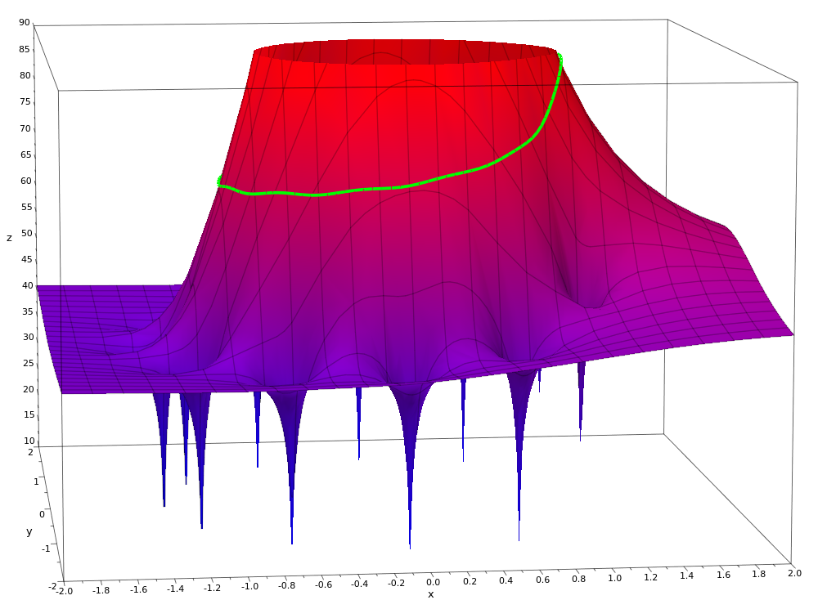

**Figure 21**: 3D Plot of H(z)

As sample data points are multiplied by their respective coefficant, they are summed and stored in a variable called ‘z’. The sum is returned to the checkForBeat() function, bit-shifted to the right by 15 bits. The multiplication and summation process as implemented in the firmware is found below where mul16() is a function which multiplies two 16-bit integers and returns a 32-bit integer:

int32_t z = mul16(FIRCoeffs[11], cbuf[(offset - 11) & 0x1F]);

for (uint8_t i = 0 ; i < 11 ; i++)

{

z += mul16(FIRCoeffs[i], cbuf[(offset - i) & 0x1F] + cbuf[(offset - 22 + i) & 0x1F]);

}

**Error Checking and Removing Further Noise**

Various forms of error checking are required when implementing this algorithm as noisy signals can be generated from incorrect placement and movement. The first form of error checking can be found in the main loop() function before calculateHR() is called. This check ensures that a certain time has passed since the last time the heart rate was calculated, saving on processing power. Also, this statement also ensures that a heart rate above 120 beats per minute is calculated.

if(millis()-timeLastHRBeat > 500)

A second form of error checking is used after the infrared value is obtained from the MAX30102. In addition to a beat being detected, the infrared value must also be above a certain threshold to ensure that the light emitted from the sensor is actually being reflected off something.

if (checkForBeat(irValue) == true && irValue > 50000)

One final form of error checking is used to eliminate time difference values which would result in unrealistic heart rate values. Only values between 40 and 120 beats per minute are considered before they are inputted into an array containing the past 5 heart rates.

if (heartRate < 120 && heartRate > 40)

**3.3 Accelerometer**

11/01/17

Tynan Sears

To calculate steps taken by the user wearing the watch, quaternion values obtained from the MPU-6050 are used. These values are extracted from a FIFO buffer which is outputted by the MPU-6050’s digital motion processor. Using the I2Cdevlib library, the desired processed values from the FIFO buffer such as accelerations, rotatations, temperature, and quaternions can be easily read from the DMP.

Quaternions are used to represent the rotation of a body in 3D space relative to an inertial frame of reference. A quaternion is comprised of a scalar component and a complex vector component, where the scalar component is the rotation of a body, or point, around the vector component. Any movement in 3D space can be defined by a quaternion vector. A simple example of a unit vector and its rotation scalar can be found in **Figure 22**. A rotation using quaternions is calculated by multiplying multiple quaternions together, as when complex vectors are multiplied together they result in a rotation. For the step detection algorithm, only the scalar quaternion value was used as it delivers the most stable and reliable data which was discovered through rigorous testing and analysis.

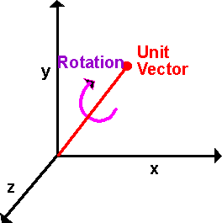

**Figure 22:** Quaternion Vector and Scalar Component

**Algorithm**

The function affiliated with counting steps is the countSteps() function which is called every time an interrupt occurs signalling new data is available from the DMP.

Once the function is called, its first task is to check whether the FIFO buffer contains an incomplete data set or if it contains any leftover data. If so, it resets and clears the buffers. This prevents the buffer from overflowing and causing data to possibly become corrupted. If the buffer is clean, data is pulled into it from the DMP until a complete data package has been received. The quaternion values are obtained and set to an object called ‘q’. The scalar component of the quartnenion can than be obtained by calling:

mpu.dmpGetQuaternion(&q, fifoBuffer);

currentQData[2] = q.w;

This function uses 3 quaternion values to determine whether a peak or trough has occurred. It determines if a peak was just processed if the middle value was the greatest of the three and if a trough was just processed if the middle value was the least of the three.

**Determining Steps**

Peak and trough values are constantly updated and if the difference between the two most recent peak and trough values exceed a threshold, a step has been detected as seen in the code snippet below. The variable ‘stepCount’ is updated and made available for the display.

double maxMinDiff = stepMax - stepMin;

// if a step is detected

if (maxMinDiff > stepDiffMinThreshold)

{

stepCount++;

}

**Analysis of Quaternion Data**

**Figure 23** is a plot of the quaternion values over 150 steps where the red circles represent where a peak was detected and a green circle represents where a trough was detected.

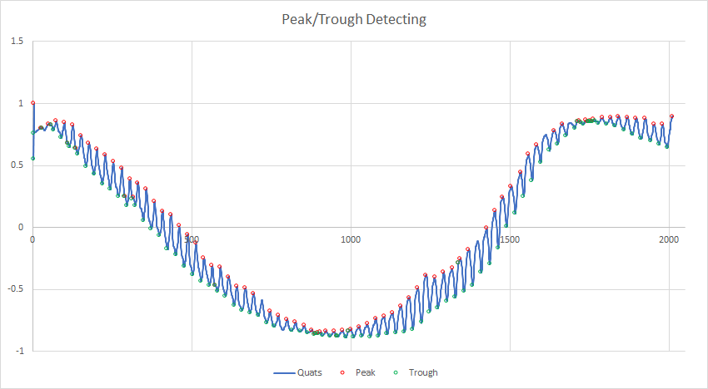

**Figure 23:** Regular Walking Sample with Peak/Trough Detection

After analysis of the collected data, it was determined that the increase in the scalar quaternion value generally corresponds to movement of the wrist as it travels backwards during a step while the decrease in the quaternion value corresponds to the forward movement/rotation of the wrist. Analysis of numerous data sets acquired through wearing the watch in different scenarios also lead to the determination of the threshold in which a movement, represented by the corresponding difference between related peaks and troughs, would be classified as a step.

**3.4 Bluetooth Communication**

09/24/17

Daniel De Sousa

The module uses the BlueCreation Melody Smart software stack to communicate with the application client on the mobile phone. This is the default Bluetooth stack loaded on the module.

The Bluetooth firmware is responsible for obtaining data received on the SAM D21 UART interface connected to the BC118.

**Setup**

To begin using the BC118 BLE module, the module must be initialized with certain configurations in order to be used properly and setup into peripheral mode. First of all, the module must be reset and the default configuration must be written to it. Furthemore, the module is placed into peripheral mode by first sending a command to enable advertising, setting specific parameters such as the advertising rate to ‘FAST’ and the advertising timeout to infinity. Finally, the device is configured to connect to any type of device and the device is reset. All of these commands are sent from the setupBLE() function which is called once in the setup() function.

**Packet Processing**

Once setup, to determine whether data is available, the following command may be called:

Serial1.available()

If this command returns ‘true’, we read a character from the UART line. A string is concatenated until the concatenated string ends with ‘\n\r’ indicating the end of a message. If the concatenated string begins with ‘RCV=’, it is a valid message from a mobile device. If not, the string is reset and the firmware begins to look for another valid message. If ‘RCV=’ is present at the beginning of the string, the message type then needs to be determined. The following message formats are valid:

* RCV=D: - Contains the date
* RCV=T: - Contains the current time
* RCV=C: - Contains phone number of contact calling device
* RCV=M: - Contains phone number of contact messaging device

Once the message type is determined, the firmware parses the incoming data packages into its associated variables and makes them available for other peripherals such as the display to use. After this is done, the string is reset and the process begins again.

**3.5 Display**

12/27/17

Daniel De Sousa

The display firmware uses the u8g2 library to interface between the microcontroller and SSD1306 display driver. The display is updated every time a message is sent from a mobile device over Bluetooth or every 1 second if a Bluetooth device is not connected. The display is updated using a 1KB display buffer which contains information on which pixels need to be activated on the monochrome display. The main display screen displays the date,time, connection and battery status, the users heart rate, and the number of steps taken by the user. A sample of the main screen can be found in **Figure 24**. When an incoming call or text is detected, the display switches to a screen which contains the message, the phone number, time, and date as seen in **Figure 25**.

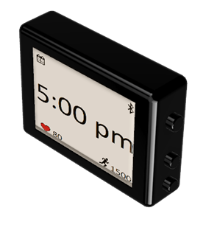

**Figure 24**: Sample Display

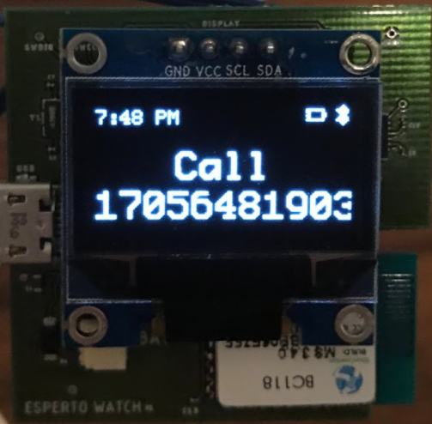

**Figure 25**: Display After Receiving Incoming Notification

**3.6 Real Time Clock**

12/27/17

Daniel De Sousa

The internal RTC (Real Time Clock) is used to keep track of the date and time when the watch is not connected to a mobile device. The firmware uses the RTCZero library which is used to communicate with the internal RTC found on the SAM D21.

**RTC Setup**

For the RTC to be used to keep track of the current time, some conditions need to be met as outlined by the following if statement in the firmware:

if((isBTConnected == true || isRTCInit == true) && ((millis() - btLastConnected) > 10000) && lastSecondDisplayUpdated != rtc.getSeconds())

This statement allows us to check for if the right conditions are met to use the internal RTC instead of the mobile device to keep track of time. The first condition which has to be met requires either Bluetooth to have been recently connected or the RTC to have been initialized. The second condition requires a mobile device to have not sent any messages to the watch in the past 10 seconds, ensuring that Bluetooth is now disconnected. The final condition prevents the firmware from repeatedly updating the display when not needed. This check ensures that the OLED display is only updated once a second, saving processor power.

The RTC is only initialized every time that a Bluetooth connection between the watch and a mobile device has been terminated. The function setRTCTime() sets the RTC’s time and date using the latest time and date messages obtained from the mobile device.

**3.7 Power Management**

10/16/17

Daniel De Sousa

The only firmware pertaining to the power management circuit consists of reading the output battery voltage and reading the USB power line. Using these readings, it can be determined whether the battery is low and needs charging and if the USB is being powered and therefore charging the battery. This information can then be made available to the user using the display.

**Algorithm**

The microcontroller reads the input voltage using its analog pins. The internal analog to digital converter then converts this value to a digital value between 0 and 4095. Analog signals have 4096 discrete values in this setup due to a 12-bit ADC bus (2^12 = 4096). First, a percentage is obtained by dividing the analog signal read and the max analog value possible (4096) and then multiplied by the reference voltage (3.3V).

As noted in **Section 2.7**, there are two voltage divider circuits before each of the analog inputs mentioned above to not damage the 3.3V tolerant ADC pins found on the SAM D21. In order to determine whether the battery requires charging (battery voltage is less than 3.6V), the firmware checks whether the analog pin has a value less than 1.8V (3.6/2 = 1.8). If so, the battery requires charging. To check if the USB is plugged in and charging the battery, the firmware checks the specific analog pin for a value greater than 1V. If it is greater, the USB port is being powered and the battery is being charged. This information is made available to the user via the watch display.

**4. Application**

This section describes the mobile application used to connect and exchange data with the smartwatch.

**Version 1.2.1**

09/24/17

Daniel De Sousa

The mobile application is built on the Android operating system and is confirmed to operate both on the Oreo 8.0 and Nougat 7.1 versions of the OS. The purpose of this application is to allow for testing and functionality of the Bluetooth Low Energy protocol between the mobile device and the BC118 module.

**Functionality**

When opened, the user selects the Bluetooth button which opens a menu with all the possible nearby BLE devices to connect to. The user selects the ‘Esperto Smartwatch’ device and the application will instantly change its connection status to ‘Connected’ and begin streaming information to the device.

**Layout**

The layout of the application is simple with a logo, a button to connect to a device, and a connection status label. An image of the layout can be seen in **Figure 26.**

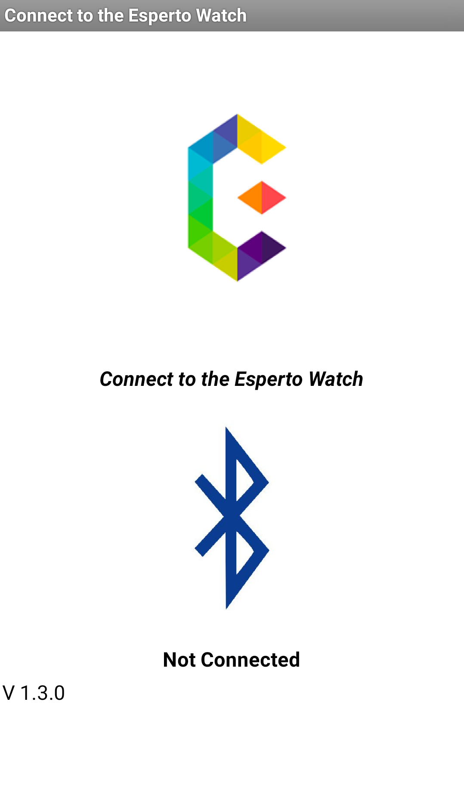

**Figure 26:** Application Layout

**Algorithm**

The Esperto mobile application is an interrupt based application which uses the mobile phone's internal clock to sample data such as the date and time from the phone at a set frequency. When sampling, the application obtains the phone's current date, time, and notifications about any incoming calls or text messages. The application sends 4 different types of messages containing either the current date, time, text, or call notifications. It sends these notifications at different time intervals. For example, current time information is sent every 2.5 seconds while date information is only sent every 30 seconds. Call and text notifications are only sent when the mobile device receives a call or text message. These messages are continuously transmitted for 5 seconds and then terminate.

At startup, the application commands the mobile device to begin scanning for BLE enabled devices such as the watch. When the Bluetooth logo is selected, a list appears allowing the user to choose between devices. Once selected, the application connects the mobile device to the address of the device chosen.

Every time the application sends a message, it requires a service and characteristic UUID or a Universally Unique Identifier. These identifiers specify which services and characteristics are being used which are based on both the module being used and the specific Bluetooth stack implemented on the chip. The following are the service and characteristic UUIDs used in this application:

Service UUID: BC2F4CC6-AAEF-4351-9034-D66268E328F0

Characteristic UUID: 06D1E5E7-79AD-4A71-8FAA-373789F7D93C

Before sending the message to the BC118, a final step is required in appending a message identifier to the beginning of the string such as ‘D:’, ‘T:’ ‘M:’ ‘C:’ which specifies which type of message is being sent.

**5. Printed Circuit Board**

This section provides an overall view of the PCB layout and board design.

**5.1 PCB Layout**

12/29/17

Daniel De Sousa

**Overall Layout**

The board schematic and layout are designed using EAGLE. The overall board dimensions are 40 x 40 mm and contains 17 unique components excluding the external display and heart rate sensor.

The board is a 2-layer board where both the top and bottom planes act as ground planes except underneath the BC118 RF antenna. Signal traces can be found both on the top and bottom layer but components are only found on the top layer. The complete layout can be found in **Figure 27.**

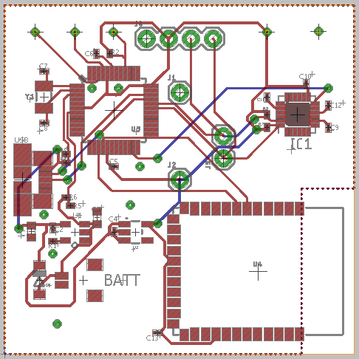

**Figure 27:** Esperto Watch Board Layout

The locations of each of the components are as follows:

* SAM D21 Processor: Top Left
* USB Port: Center Left
* Battery Connector: Bottom Left
* Accelerometer: Top Right
* Bluetooth: Bottom Right

**Special Design Considerations**

The first design consideration which needed to be taken into account was how to program the SAM D21 processor with the Arduino bootloader. As seen in **Figure 28**, 3 extra vias were added in order to connect to an external Atmel Ice Debugger. These vias lead to the RST, SWDIO, and SWSCK pins on the SAM D21. This RST pin can also be tied to GND to reset the watch.

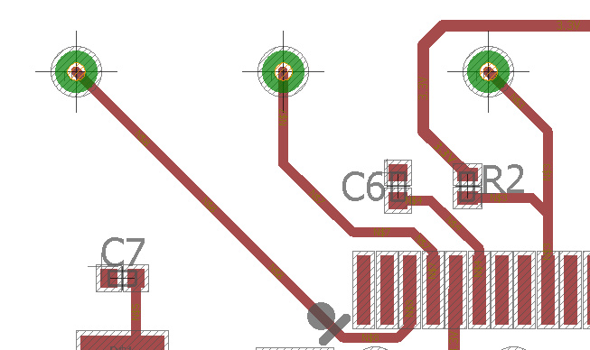

**Figure 28:** Vias Used to Program the SAM D21

The second design consideration which needed to be implemented was how to connect the external display and heart rate sensor. 0.1” spaced vias were added in exact positions to allow the user to connect the new PCB to the external peripherals as seen in **Figure 29**. Vias found at the top of the board will connect to the external display while 4 vias found in the middle of the board will connect to the heart rate sensor from below.

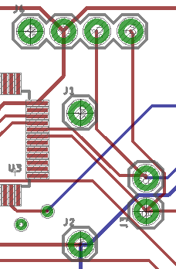

**Figure 29:** Vias Used to Connect to External Display and Heart Rate Sensor

**6. Mechanical Design**

01/04/18

Tynan Sears

This section describes the housing which will encase the PCB, the heart rate sensor, the battery, and the display.

**Overall Layout**

The mechanical design or watch casing was designed using AutoCAD Fusion 360. The outer dimensions of the design are 46mm x 46mm x 18.5mm, allowing for a general wall thickness of 2mm to provide necessary support and protection for the PCB and other internal components. The interior dimensions of the casing are 42mm x 42m x 13mm, leaving a 1mm buffer for all sides of the PCB to easily fit into the case. In addition to the PCB, the PPG sensor, display, and battery also needed to be considered when designing the interior of this case as these components are not found on the PCB itself.

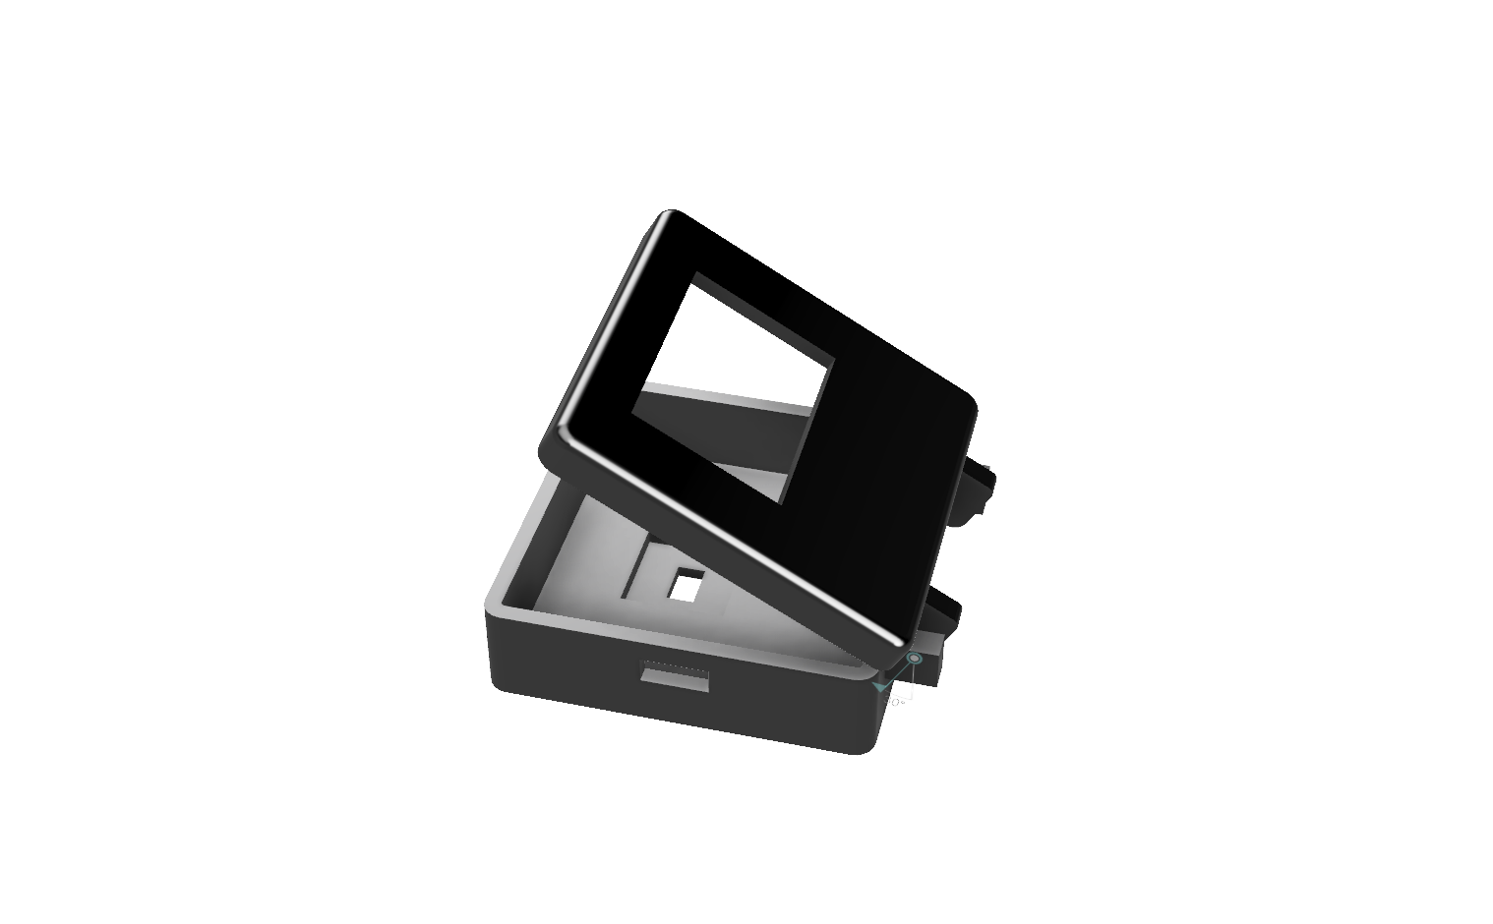

**Figure 30:** Mechanical Design Assembly for Watch Casing

**Special Design Considerations**

When designing the case for the watch it was important to take into consideration the accessibility to the PCB for removability to allow for future work to be done on the PCB without any case interference. It is also possible that the existing PCB could be replaced in the future, while still using the existing mechanical design, so to be able to remove the current PCB is important. These considerations lead to the addition of the hinged connection between the top and bottom piece of the casing.

Another important design consideration was the placement of external components such as the PPG sensor, display and battery, which were not included directly on the PCB. These components are soldered onto the board. When designing the mechanical casing it was extremely important to take into account the size of these components and where they would be placed within the casing. The PPG sensor will be placed in the extrusion and opening found on the bottom of the design, while the micro USB will be accessed using the cutout on the side and the display will be held against the opening on the top of the watch case as seen in **Figure 30**. The battery will be placed between the display and PCB.

**7. Communication Protocols**

This section describes the different communication protocols which the microcontroller uses to communicate with the various peripherals or any other protocol involved in this project.

**7.1 Serial Communication** 09/24/17

Daniel De Sousa

Serial communication is a form of wired communication between devices. The protocol is highly configurable but requires both devices or busses to be configured with the same settings.

One of the settings which need to be configured is the baud rate which determines how fast data will be sent via the serial line. It is measured in bits per second (bps). Common values are 9600 or 115200 bps.

In serial communication, information is sent in a data frame or data packet which consist of synchronization and parity bits appended to the actual data information. A typical data frame can be seen in **Figure 31**.

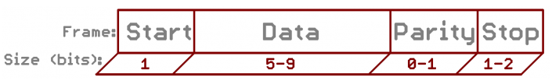

**Figure 31**: Typical Data Packet Sent Via Serial Communication

Synchronization bits are the start and stop bits located at the beginning and end of each package. Parity bits are error checking bits which are often used in noisy mediums but do not need to be used in settings with little to no noise.

A serial bus consists of 2 pins in addition to the mandatory pins such as GND and VCC. The two pins are TX and RX which represent the transmitting and receiving pins respectively. The TX pin of one device connects to the RX of the other device as one device will be sending information while the other one will be receiving it as seen in **FIgure 32**.

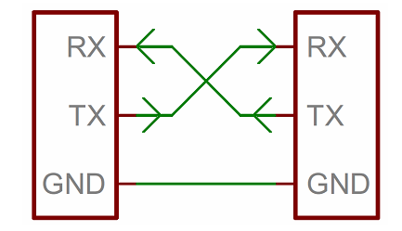

**Figure 32**: Hardware Layout for a Serial Interface

A serial interface may be full-duplex where both devices are able to send data simultaneously, half-duplex meaning devices may take turns sending and receiving data, or simple duplex where one device receives and the other transmits.

Devices send these signals by using methods such as TLL (transistor-transistor logic) serial which consists by varying the voltage supply as seen in **Figure 33.**

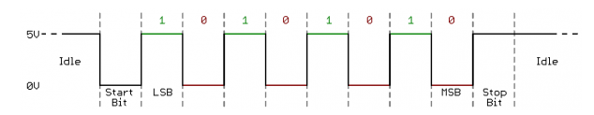

**Figure 33:** Example of TLL Serial Signal

Finally, the UART or Universal Asynchronous Receiver/Transmitter is used to implement serial communication by creating, sending, receiving, controlling the hardware lines, and at times, buffer data in a FIFO manner. They can be found as external circuits or within microcontrollers. The UART acts as an intermediary between parallel and serial interfaces containing a number of data lines and control pins and TX and RX lines on the other side as seen in **Figure 34.**

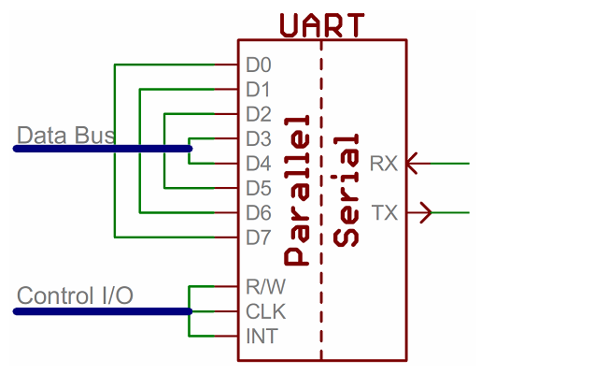

**Figure 34**: UART Bus

**7.2 I2C Communication**

11/02/17

Tynan Sears

Inter-Integrated Circuit (I2C) communication is a synchronous protocol that uses a serial data line (SDA) and a serial clock line (SCL) to exchange data between two devices. I2C devices can either take the master or slave role where the master controls the SCL line. I2C supports multiple slaves and masters as seen in **Figure 35.** The master differentiates between slave devices by their specific set addresses.

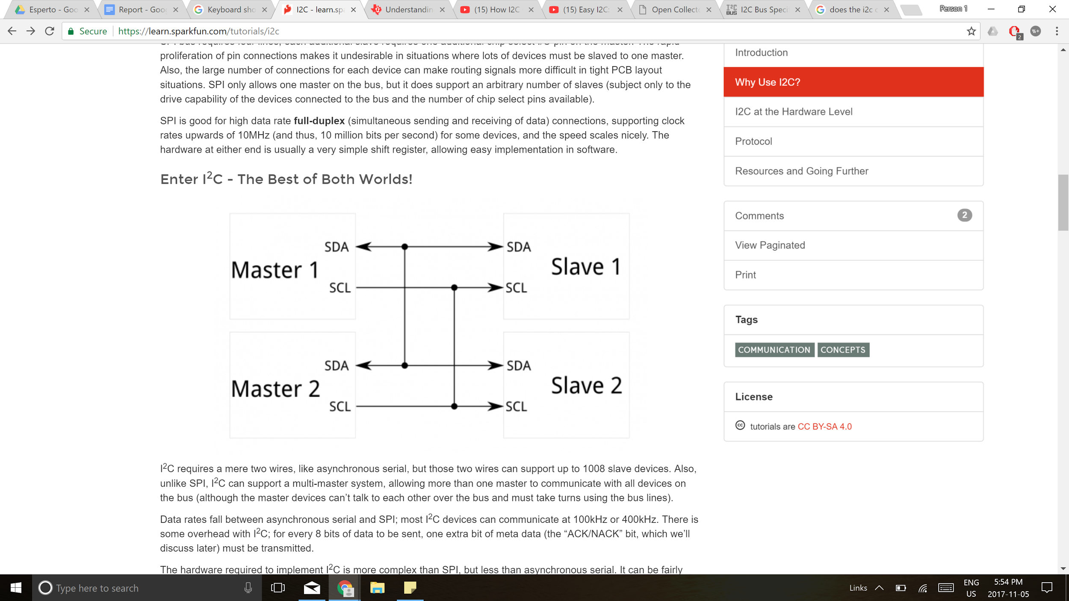

**Figure 35**: Hardware Layout for an I2C Interface

The SDA line runs high with the use of a pull up resistor and may be pulled down using an open drain driver by either a slave or master device to allow for bidirectional data transfer. The SCL line fluctuates between high and low at a frequency set by the master device creating a clock signal. The SCL line is used to maintain synchronicity between devices but can also be pulled low to allow the slave device to send data to the master device. **Figure 36** shows the schematic layout of how the aforementioned process works.

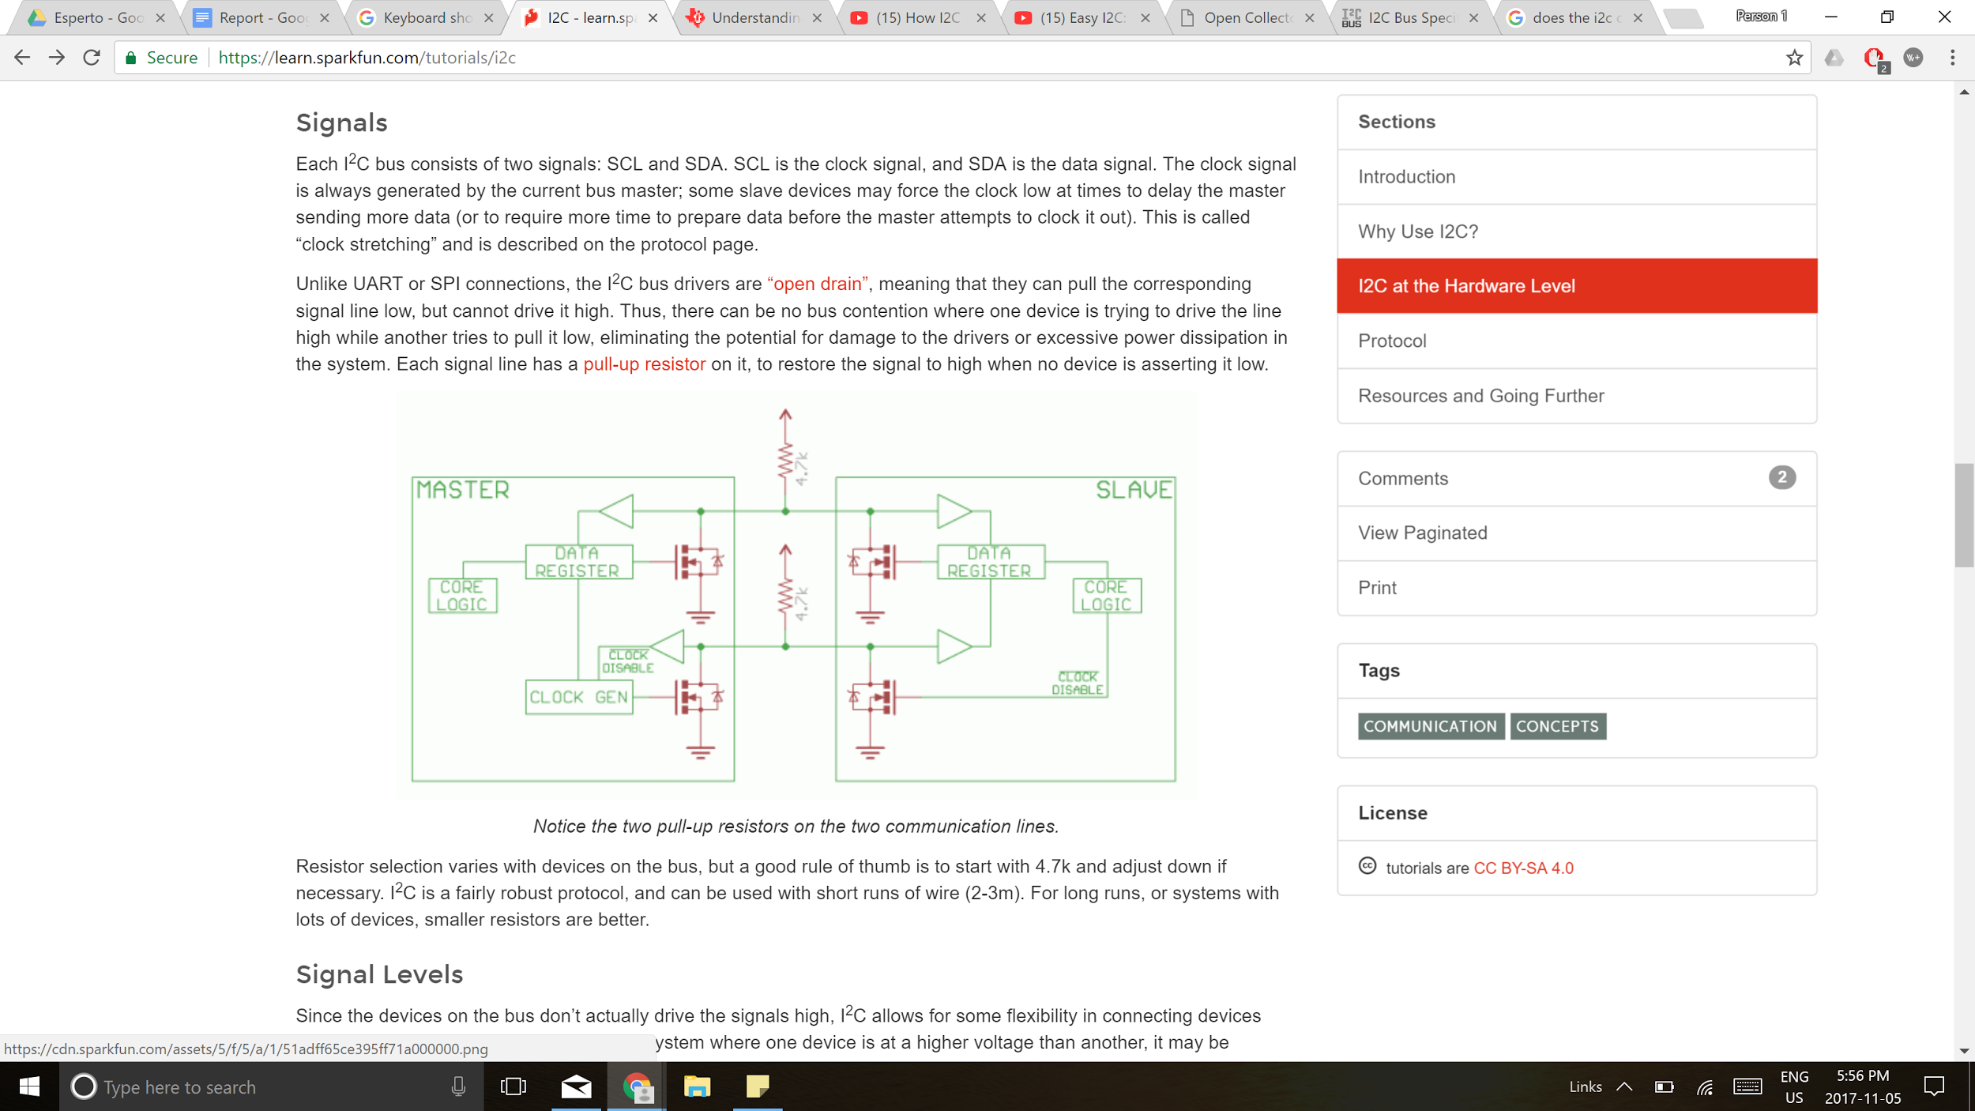

**Figure 36:** Typical Schematic of I2C Interface

Data transfer is initiated by the master by sending a start bit followed by the slave device address, the data frame, and a stop condition. A start bit is composed of driving the SDA line low while leaving the SCL line high. The slave address is a 7-bit address, read in order of MSB, ending in a read/write bit, and a ACK/NACK bit. If the slave device is able to pull the SDA line low then an ACK bit is returned. Data is then sent using the SDA line at an interval set by the SCL line. At the end of a data transfer, the master will initiate a stop bit driving the SDA line from low to high while keeping the SCL line high. An example of this process can be found in **Figure 37**.

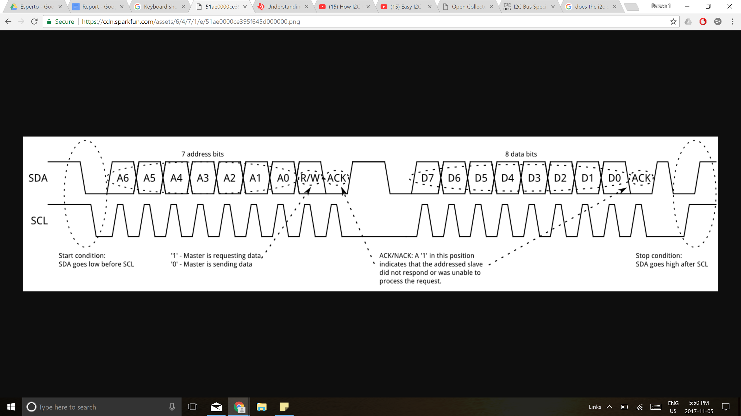

**Figure 37:** SDA and SCL Lines During I2C

**7.3 Bluetooth Classic**

09/24/17

Daniel De Sousa

Bluetooth is a technology standard used to wirelessly exchange data between devices over short distances. The technology uses short-wavelength ultra-high frequency radio waves at frequencies in the range of 2.4 to 2.485 GHz to send commands and data. It was invented to replace traditional cables and make data exchange wirelessly between devices. Bluetooth technology uses a method of transmitting radio signals called Frequency-Hopping Spread Spectrum (FHSS). This method consists of emitting short bursts of data and quickly “hopping” to different frequencies within its range. This allows multiple devices to be connected to one host device and eliminates data interference between different channels.

**7.4 Bluetooth Low Energy** 12/27/17

Daniel De Sousa

Bluetooth Smart or Bluetooth Low Energy (BLE) is a reduced power consumption alternate version of the Classic Bluetooth protocol. The protocol works very similarly to Classic Bluetooth in the sense that it uses frequency hopping to transmit data without any interference from other devices but instead uses 40 2-MHz channels compared to the 79 1-MHz channels found in Classic Bluetooth.

The most significant difference between the two protocols is that Bluetooth Smart does not maintain a constant data connection between devices while Classic Bluetooth ensures a constant connection exists between devices. Bluetooth Smart enabled devices only send data when needed which ensures that less power is used but also decreases the maximum possible bandwidth, the amount of data that can be transmitted in a fixed amount of time.

Bluetooth Smart is perfect for devices that do not frequently transmit large amounts of data and need to operate for long periods of time on a battery.